EEXPERIMENT 27
After modifying a file in a cloned repository, commit the changes
locally and push them to GitHub.
Tasks:
• Clone a repository (from question 1).
• Modify a file (e.g., README.md).
• Stage the changes with git add.
• Commit the changes with git commit -m &quot;Updated
README&quot;.
• Push the changes to GitHub using git push.
Step 1: Go into the cloned repository
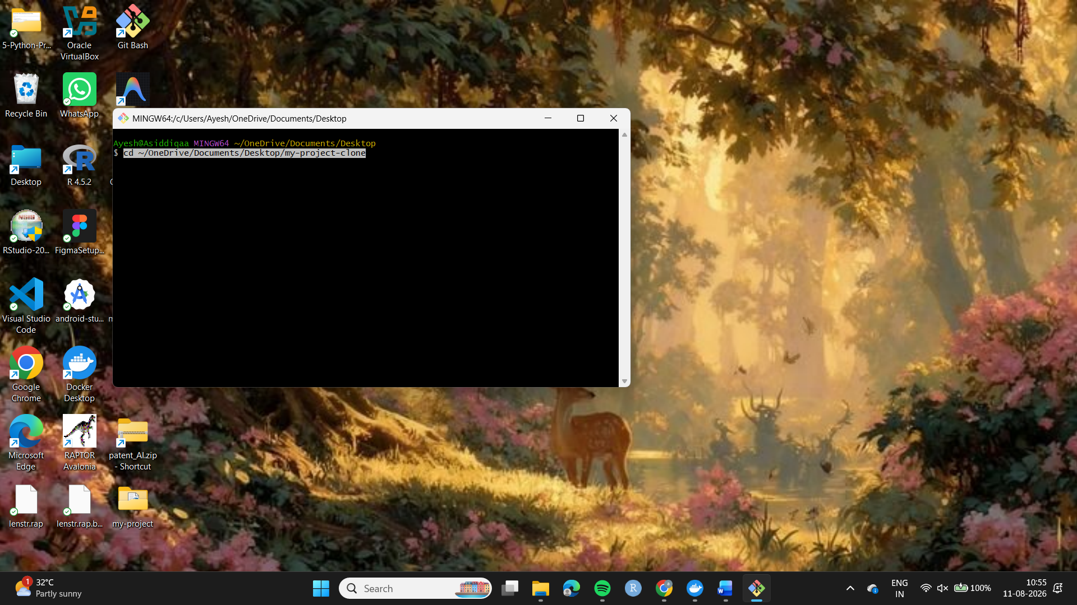

Step 2: Check your modification
Run:
git status
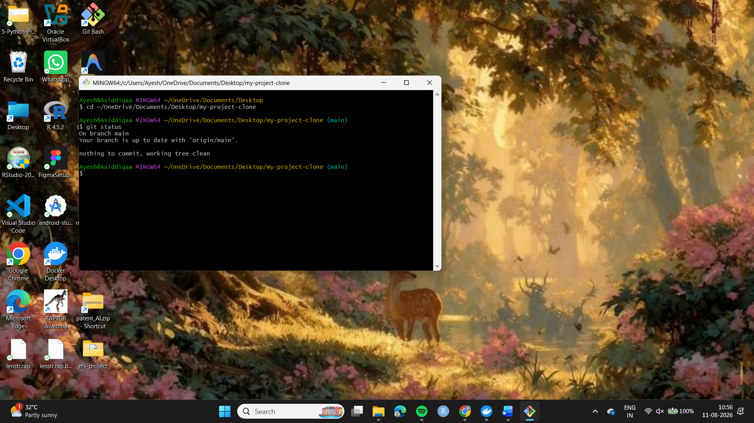
Step 3. Modify README
notepad README.md
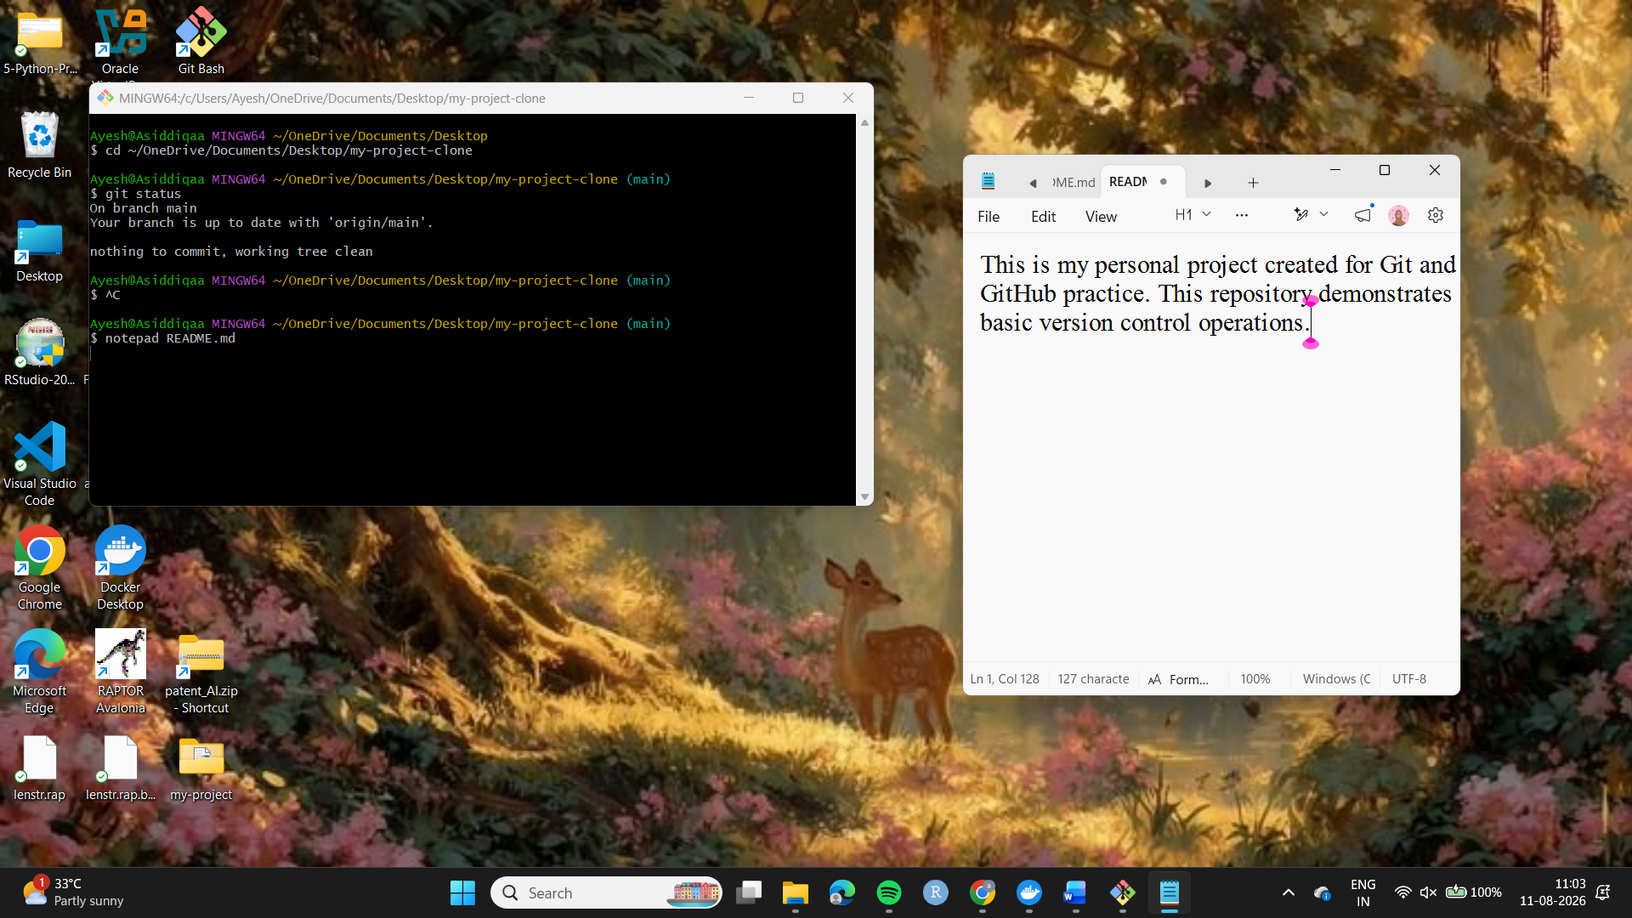
4. Check changes
git status
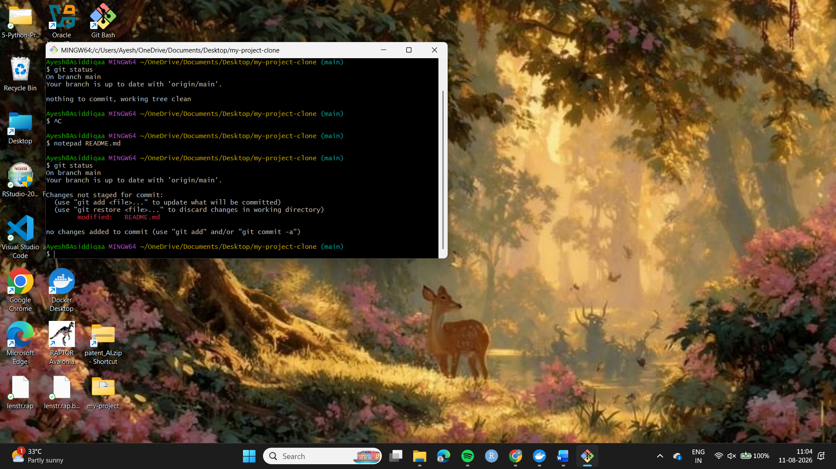
5. Stage changes
git add README.md
6. Commit changes
git commit -m "Updated README"
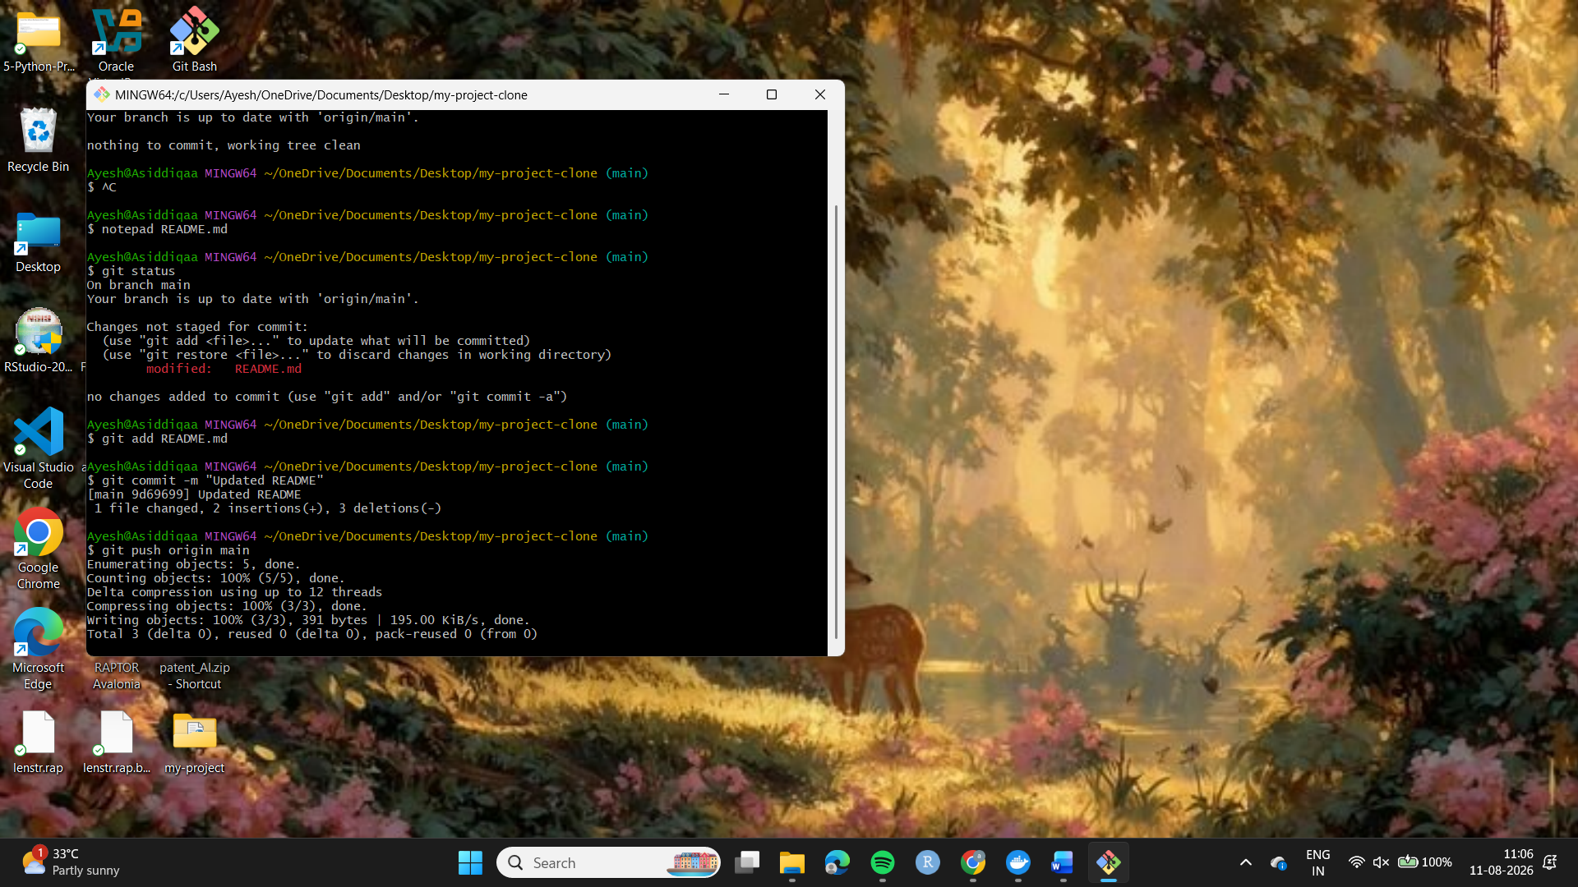
7. Push to GitHub
git push origin main
Step 8. Open the GitHub repository and confirm that the updated README.md and Updated README commit are visible.
